Blockchain and Cryptocurrency
Practical File

Submitted By

Sidra Khan
Enroll. No.: 240545002005
M.Sc. Cyber Security Semester- III

Submitted to
Mr. Yogesh Sharma

School of Cyber Security & Digital Forensics National Forensic Sciences University, Bhopal Campus, M.P., India
2025

Table of Contents
Experiment 1: Hash Functions & Hash Pointers 3
Experiment 2: Merkle Tree Implementation 4
Experiment 3: Building a Simple Blockchain 6
Experiment 4: Mining Simulation (PoW) & Dififiiculty Adjustment 7
Experiment 5: Proofi-ofi-Stake (PoS) & Proofi-ofi-Burn (PoB) Simulation 9
Experiment 6: Solidity Basic Contract (Mobile Purchase) 10
Experiment 7: Digital Forensics Chain ofi Custody 11
Experiment 8: Play with Go-Ethereum (Geth) 13

E:psrimsnt 1: H6sh Functions & H6sh Pointsrs
Objective:
Implement SHA-256, design a simple Block class that links blocks via hash pointers and detects tampering.
Theory:
A hash function takes an input message and produces a fixed-size output (hash). SHA-256 produces a 256-bit hash value and is widely used in Bitcoin for integrity. A hash pointer stores the hash of the previous block, ensuring that any modification breaks the chain.

Code (Python):

import hashlib

# 1. Implement SHA-256 def sha256(data):
return hashlib.sha256(data.encode()).hexdigest()

# 2. Block Class with Hash Pointers class Block:
def init (self, data, prev_hash=''):
self.data = data
self.prev_hash = prev_hash
self.hash = self.compute_hash()

def compute_hash(self):
return sha256(self.data + self.prev_hash)

# 3. Build a Simple Blockchain
blockchain = []
genesis_block = Block("Genesis Block") blockchain.append(genesis_block)

# Add blocks
for i in range(1, 4):
prev_hash = blockchain[-1].hash
block = Block(f"Block {i} Data", prev_hash)
blockchain.append(block)

# Display Blockchain
print("--- Original Blockchain ---") for b in blockchain:
print(f"Data: {b.data}")

print(f"Hash: {b.hash}")
print(f"Prev Hash: {b.prev_hash}\n")

# 4. Tampering Test
print("--- Tampering with Block 2 ---") blockchain[2].data = "Tampered Data" blockchain[2].hash = blockchain[2].compute_hash()

# Verify Blockchain
def verify_chain(chain):
for i in range(1, len(chain)):
if chain[i].prev_hash != chain[i-1].hash:
return False
return True

print("Blockchain Valid:", verify_chain(blockchain))

Output:
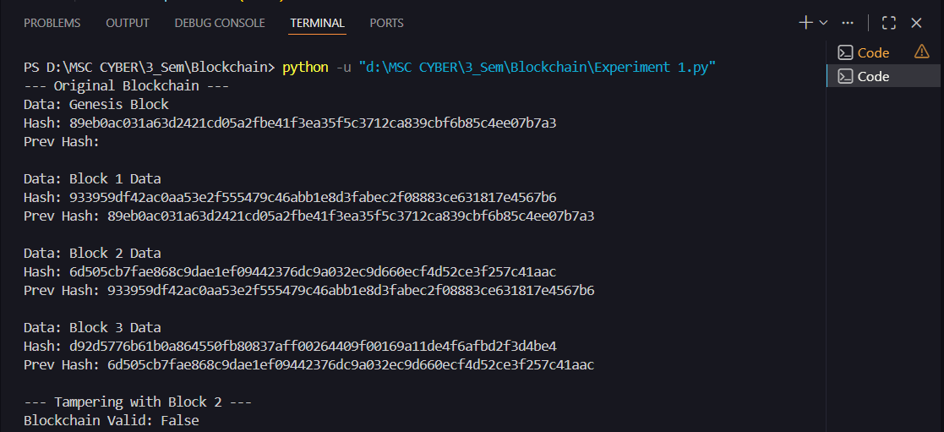

E:psrimsnt 2: Msrels Trss Implsmsnt6tion
Objective:
To construct a binary Merkle tree from a list of transaction hashes and compute the Merkle root.
Theory:

A Merkle Tree is a binary tree of hashes used to efficiently verify data integrity. Leaf nodes are transaction hashes, and non-leaf nodes are hashes of their children. The root uniquely represents all transactions.

Code (Python):

import hashlib

def sha256(data):
return hashlib.sha256(data.encode()).hexdigest()

def build_merkle_tree(transactions):
# Step 1: Hash all transactions (Leaf Nodes)
hashes = [sha256(tx) for tx in transactions]

print(f"Leaf Hashes: {hashes}")

# Step 2: Loop until root is found
while len(hashes) > 1:
# Duplicate last hash if odd number
if len(hashes) % 2 != 0:
hashes.append(hashes[-1])

new_level = []
# Step 3: Pair and Hash
for i in range(0, len(hashes), 2):
combined = hashes[i] + hashes[i+1]
new_level.append(new_hash)
new_hash = sha256(combined)

hashes = new_level
print(f"Intermediate Level: {hashes}")

return hashes[0]

# Driver Code
transactions = ["Tx1", "Tx2", "Tx3", "Tx4"] root = build_merkle_tree(transactions) print(f"\nMerkle Root: {root}")

Output:

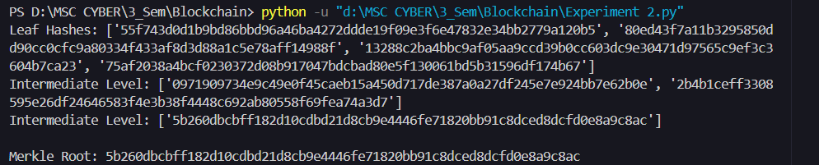

E:psrimsnt 3: Duilding 6 Simpls Dlocech6in
Objective:
To design and implement a simple blockchain that incorporates basic transactions and performs Proof-of-Work (mining).
Theory:
A blockchain consists of blocks containing an index, timestamp, data, previous hash, nonce, and its own hash. To "mine" a block, a nonce is adjusted until the block hash meets a difficulty target (starts with specific zeros).

Code (Python):

import hashlib
import time

class Block:
def init (self, index, data, prev_hash):
self.index = index
self.timestamp = time.time()
self.data = data
self.prev_hash = prev_hash
self.nonce = 0
self.hash = self.calculate_hash()

def calculate_hash(self):
block_string = f"{self.index}{self.timestamp}{self.data}{self.prev_hash}{self.nonce}"
return hashlib.sha256(block_string.encode()).hexdigest()

def mine_block(self, difficulty):
target = "0" * difficulty
while self.hash[:difficulty] != target:
self.nonce += 1
self.hash = self.calculate_hash()
print(f"Block Mined: {self.hash}")

# Initialize Blockchain
difficulty = 4
blockchain = [Block(0, "Genesis Block", "0")] blockchain[0].mine_block(difficulty)

# Add new block
print("\nMining Block 1...")
new_block = Block(1, "Transaction Data", blockchain[-1].hash) new_block.mine_block(difficulty) blockchain.append(new_block)

# Verify Integrity
print(f"\nPrevious Hash stored in Block 1: {new_block.prev_hash}") print(f"Actual Hash of Genesis Block: {blockchain[0].hash}")

Output:
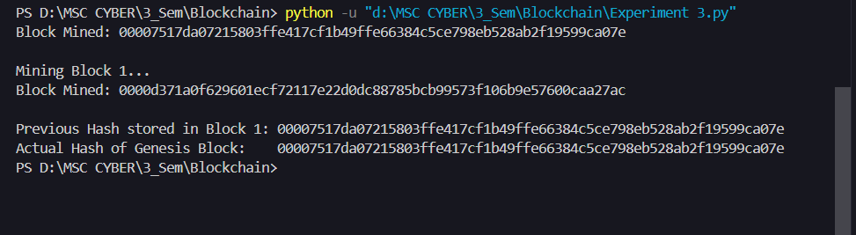

E:psrimsnt 4: Mining Simul6tion (PoW) & Dififiiculty Adjustmsnt
Objective:
To simulate Proof-of-Work (PoW), analyze the relationship between difficulty and time, and implement difficulty retargeting.
Theory:
Mining time is inversely proportional to the target value. If blocks are mined too quickly, difficulty increases (more leading zeros); if too slowly, it decreases. This keeps the block generation rate constant.

Code (Python):

import hashlib

import time

def mine(difficulty):
prefix = '0' * difficulty
nonce = 0
start_time = time.time()

while True:
text = f"message{nonce}"
hash_result = hashlib.sha256(text.encode()).hexdigest()
if hash_result.startswith(prefix):
end_time = time.time()
return end_time - start_time

# Simulation difficulties = [2, 3, 4, 5] times = []

print("Diff | Time Taken (s)") print(" ")

for d in difficulties:
t = mine(d)
times.append(t)
print(f" {d} | {t:.5f}")

# Simple Difficulty Adjustment Logic target_time = 0.5 # Seconds last_time = times[-1]

if last_time < target_time:
print(f"\nMining was too fast ({last_time}s). Increasing difficulty.") else:
print(f"\nMining was too slow ({last_time}s). Decreasing difficulty.")

Output:

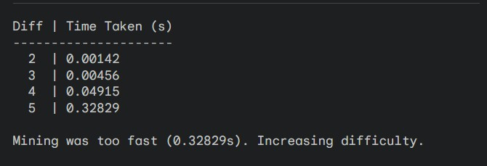

E:psrimsnt 5: Proofi-ofi-St6es (PoS) & Proofi-ofi-Durn (PoD) Simul6tion
Objective:
To simulate PoS and PoB consensus algorithms and compare their energy consumption against PoW.

Theory:
- PoW: High energy; miners solve puzzles.
- PoS: Validators are selected based on the stake (coins locked) they hold.
- PoB: Validators burn coins to increase probability of selection.
- Energy usage is estimated as $Time \times Power$ (assumed 50W).

Code (Python):

import random
import time

# Mock Data
validators = {"Alice": 10, "Bob": 50, "Charlie": 40} # Stake or Burn amount
power_consumption_watts = 50

def simulate_pos():
start = time.time()
# Selection based on weight (stake)
total_stake = sum(validators.values())
pick = random.uniform(0, total_stake)
current = 0
winner = ""

for v, stake in validators.items():
current += stake

if current > pick:
winner = v
break

duration = time.time() - start
# Artificial small delay to represent network consensus, not computation
time.sleep(0.01)
return winner, duration

print("--- Consensus Simulation ---") winner, t_pos = simulate_pos()
energy_pos = t_pos * power_consumption_watts print(f"PoS Winner: {winner}")
print(f"PoS Time: {t_pos:.6f}s | Energy: {energy_pos:.6f} J")

# PoW Comparison (using a hard-coded time assumption for contrast)
t_pow = 2.5 # Assumed seconds for a hard puzzle energy_pow = t_pow * power_consumption_watts print(f"PoW Time: {t_pow:.6f}s | Energy: {energy_pow:.6f} J")

Output:
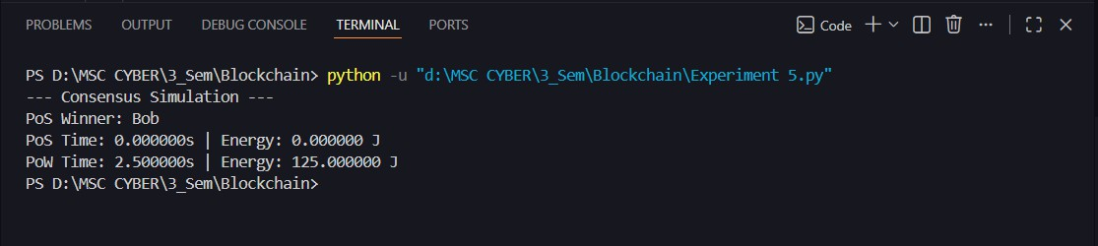

E:psrimsnt 6: Solidity D6sic Contr6ct (Mobils Purch6ss)
Objective:
To design a basic Solidity smart contract that stores mobile name and price, and retrieves details.
Theory:
Solidity is a high-level language for smart contracts on the EVM. Contracts contain state variables (stored on blockchain) and functions to modify or read them.

Code (Solidity):
// SPDX-License-Identifier: MIT pragma solidity ^0.8.0;

contract MobilePurchase {
string public mobileName;
uint public mobilePrice;

// Function to store mobile details (Write)
function buyMobile(string memory _name, uint _price) public {
mobileName = _name;
mobilePrice = _price;
}

// Function to retrieve details (Read)
function getMobile() public view returns (string memory, uint) {
return (mobileName, mobilePrice);
}
}

Output:
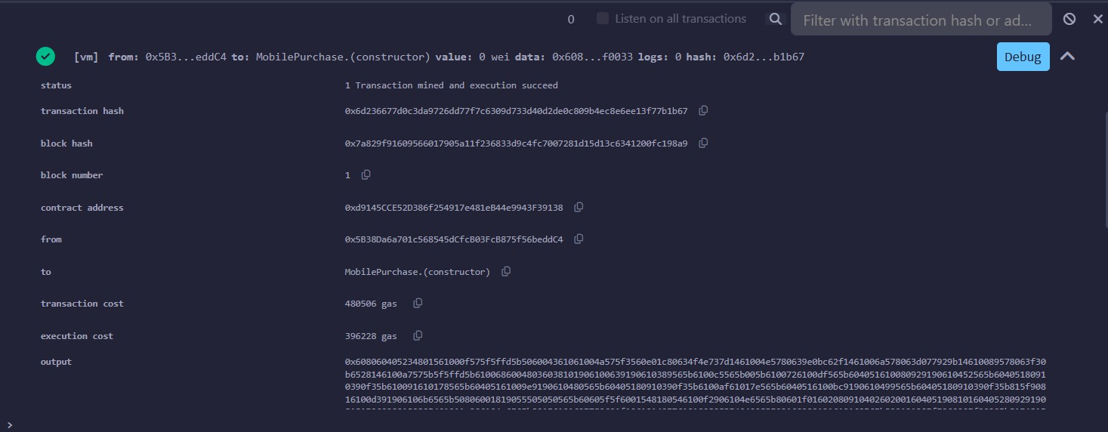

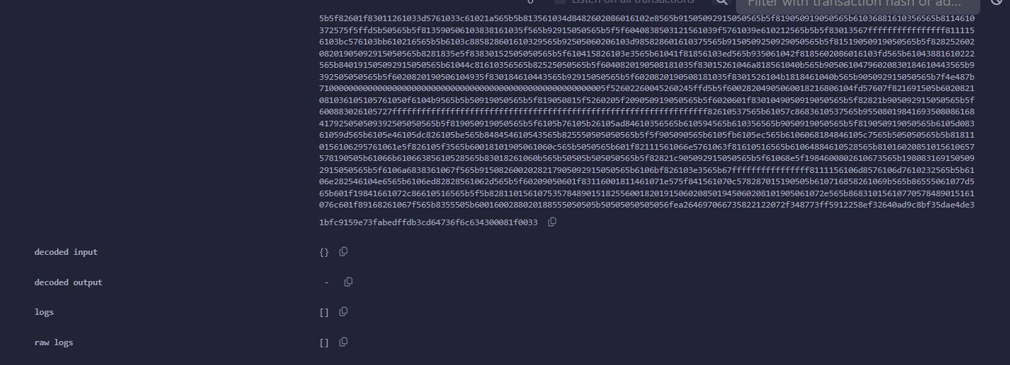

E:psrimsnt 7: Digit6l Forsnsics Ch6in ofi Custody
Objective:
To implement a Chain of Custody smart contract using structs, mappings, and events to record evidence transfers.
Theory:
Blockchain ensures immutability, making it ideal for digital forensics. We use a struct to define a custody record and a mapping to store the history of transfers for each piece of evidence15.
Code (Solidity):
// SPDX-License-Identifier: MIT pragma solidity ^0.8.0;

contract ChainOfCustody {

struct CustodyRecord {
string handlerName;
string purpose;
uint256 timestamp;
}

// Mapping: Evidence ID -> List of Custody Records
mapping(string => CustodyRecord[]) public evidenceHistory;

// Event log
event CustodyAdded(string evidenceId, string handlerName, string purpose, uint256 timestamp);

function addCustody(string memory _evidenceId, string memory _name, string memory
_purpose) public {
CustodyRecord memory newRecord = CustodyRecord({
handlerName: _name,
purpose: _purpose,
timestamp: block.timestamp
});

evidenceHistory[_evidenceId].push(newRecord);
emit CustodyAdded(_evidenceId, _name, _purpose, block.timestamp);
}

function getCustodyCount(string memory _evidenceId) public view returns (uint) {
return evidenceHistory[_evidenceId].length;
}
}

Output:
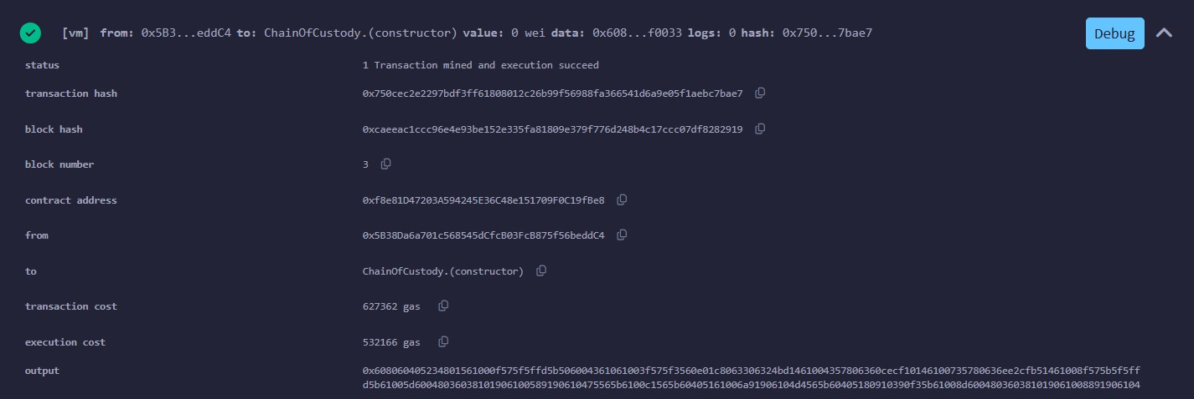
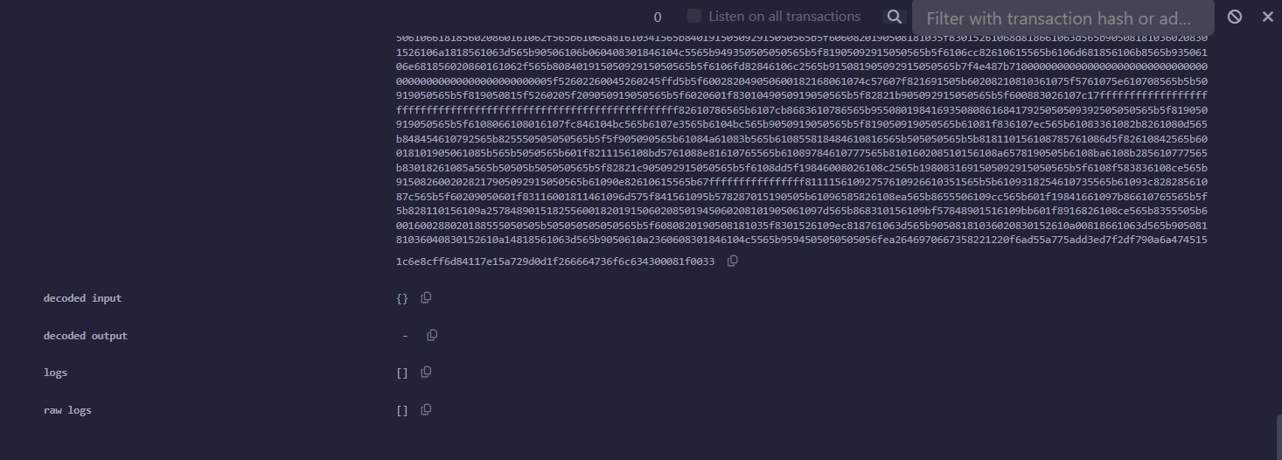

E:psrimsnt 8: Pl6y with Go-Ethsrsum (Gsth)
Objective:
To install Geth on Windows, create a private blockchain, mine blocks, and transfer ETH16. Theory:
Geth (Go-Ethereum) is a command-line interface for running a full Ethereum node. It allows creating private networks (using a custom genesis block), managing accounts, and mining blocks.

Commands Executed:
- Check Version: geth version Output:
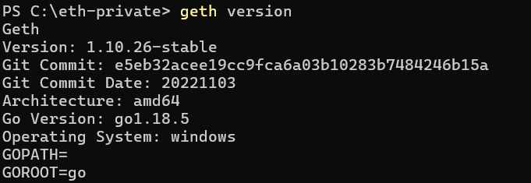

- Initialize Genesis:
geth --datadir data init genesis.json

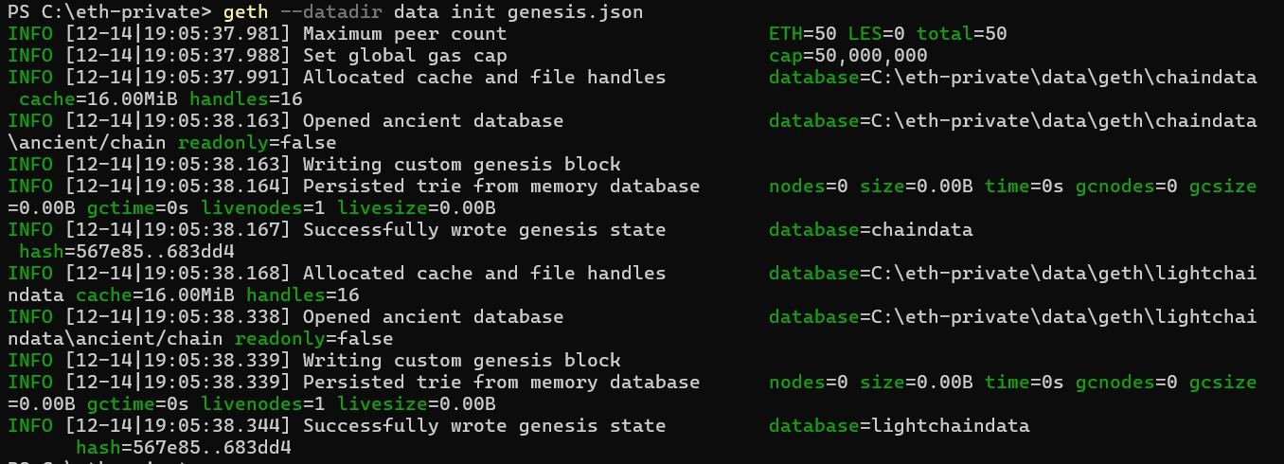
Output:

- Create Account:
geth account new --datadir data

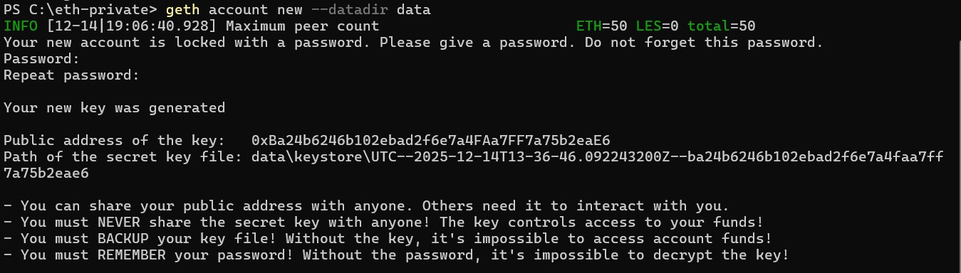
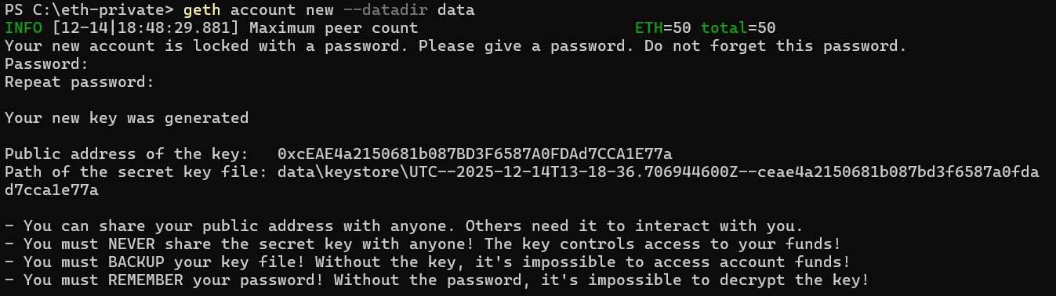
Output:
- Start Node:
geth --datadir data --networkid 12345 --http --allow-insecure-unlock console

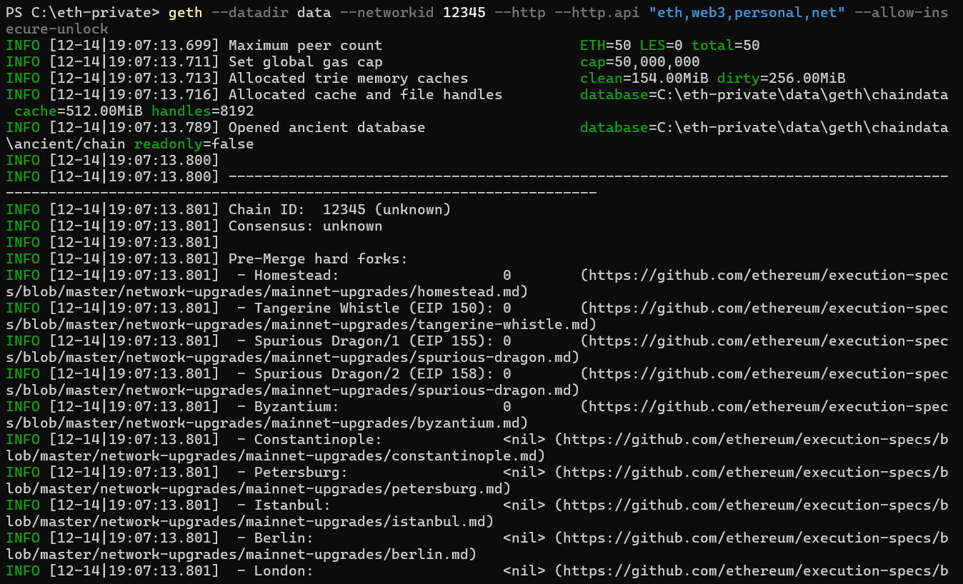
Output:

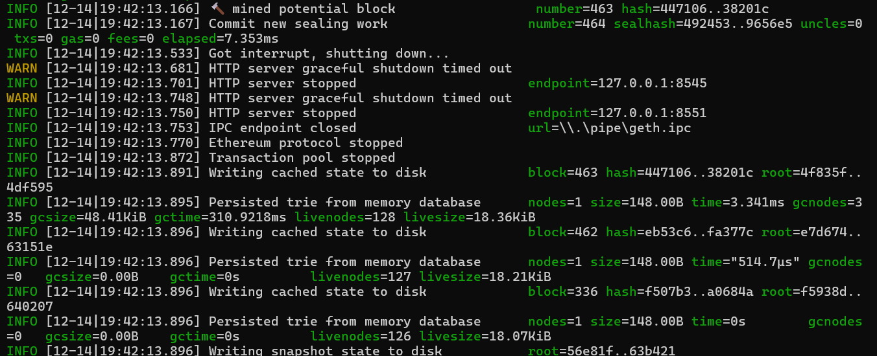

- Inside Geth Console - Start Mining: miner.start()

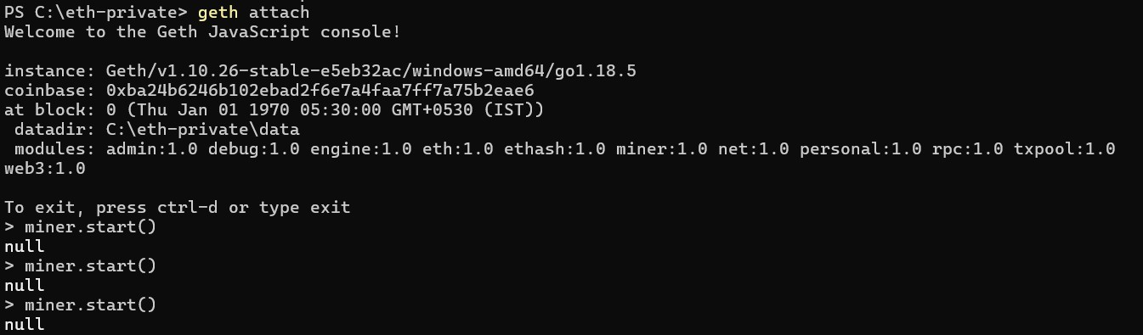
Output:
- Check Balance: eth.getBalance(eth.accounts[0])
Output:
